UNIT II

- Determine a Regular Expression over the alphabet {x,y} for the following :
i) All strings containing exactly two x's.
ii) All strings that do not end with xy.
iii) All strings starting with yy.

- Show that Q+RP=QP* for R.E P and Q over input symbol(a,b)

- For each of the following R.E., draw a F.A. recognizing the corresponding language.
i) (1+10+110)*0 ii) 1(01+10)*+0(11+10)*
- State and explain the applications of R.E.
- For each of the following draw DFA of following regular expression :

i) (11+00)* ii) (111+100)*0
- Differentiate between Finite automata and Regular expressions.
- State and explain closure properties of RE.
10.Find RE corresponding to each of the following subset of {0,1)*
- The language of all strings containing exactly two 0’s.
- The language of all strings containing at least two 0’s.
- The language of all strings that do not end with 01.
11. Use Arden’s theorem to determine RE for given FA.
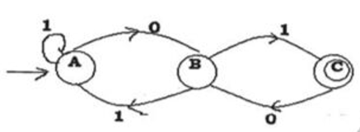
12.Write R.E. for following
i) ∑=(0,1) odd number of 1’s in a string.
ii) ∑=(0,1) triple 0 must never appear in a string.
13. Draw FA for following Regular expressions:
i) 10+(0+11)0*1
14. Draw FA for following Regular expressions:
i) 0+10*+01*0

15. Use Arden’s theorem to determine RE for given FA.
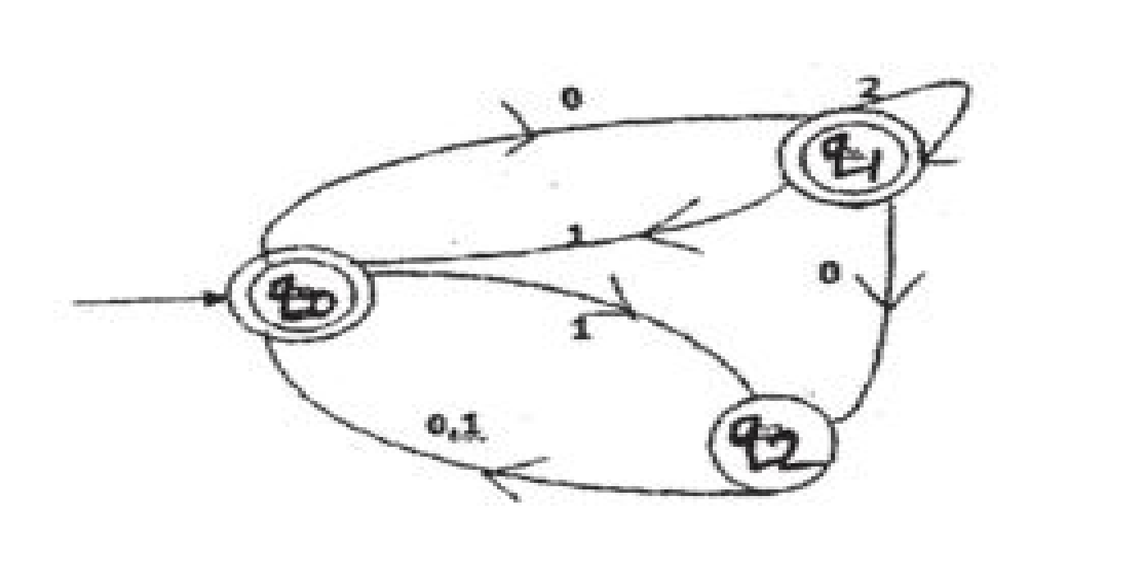

16.Prove the following formulas:
i) (r * s*)* = (r + s)*
17. Construct FA for regular expression: (11)*.010. (11)*

18. Convert the following finite automation into its equivalent regular expression using Arden’s theorem

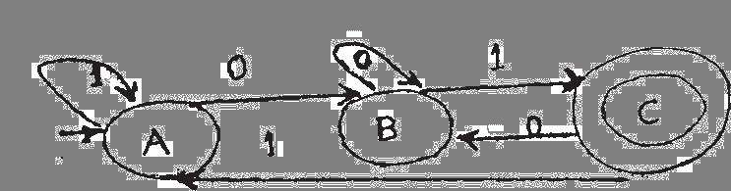

19.Prove the following formulas:
ii) (ab)* ≠ a* b*.

20. Find the regular expression for the set of strings recognized by the given FA .Use Arden’s theorem

